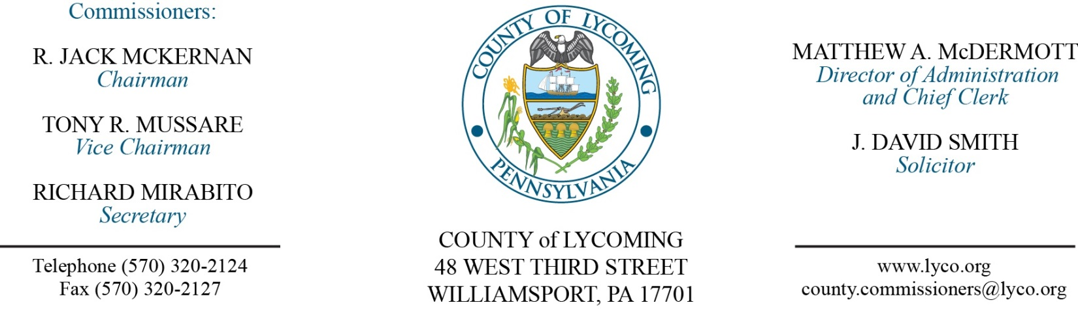
Commissioners’ Meeting Agenda
August 4, 2016

Opening Prayer

Pledge to the Flag

1.0 OPERATIONS

1.1 Convene Commissioners’ meeting.

1.2 Approve the minutes of the previous meetings.

1.3 Receive public comments (agenda items only).

2.0 ACTION ITEMS

2.1 Approve professional service agreement with Robert Cronin for conflicts attorney not to exceed $35,000/annually. (Adrianne Stahl)

2.2 Approve professional service agreement with Bearing & Drive Solutions, IV, Inc. on an as needed basis. (Jason Yorks)

2.3 Approve professional service agreement with Arraya Solutions not to exceed $27,000. (Karl Demi)

2.4 Approve professional service agreement with Arraya Solutions not to exceed $20,000. (Karl Demi)

2.5 Approve master lease agreement with EMC Corporation. (Karl Demi)

2.6 Approve lease agreement with Blast IU 17. (John Yingling)

2.7 Approve 2016 PHARE grant application to PHFA in the amount of $1,100,000. (Kim Wheeler)

2.8 Approve application to the US EPA for Brownfields Area-Wide Planning Grant in the amount of $200,000. (Joshua Schnitzlein)

2.9 - Approve personnel actions: (Roxanne Grieco)
Prison – Joel A. Worthington as full time replacement Correctional Officer Relief – COI - $15.54/hour effective 8/7/16.
Prison – Carl John L. A. Fry as full time replacement Correctional Officer Relief – COI - $15.54/hour effective 8/7/16.
Prison – Dean T. Smith as full time replacement Correctional Officer Relief – COI - $15.54/hour effective 8/7/16.
Assessment – reclassification of Brooke E. Wright as full time Chief Assessor – Pay grade 10 - $53,000/annually effective 8/14/16.

5.0 REPORTS/INFORMATION ITEMS

5.1 Big brothers big sisters media release. (Paulette Clementoni)

5.2 Drought watch in Lycoming County. (John Yingling)

6.0 PUBLIC COMMENT:

7.0 NEXT REGULARLY SCHEDULED MEETING: Planning Session on Tuesday, August 9, 2016.

8.0 ADJOURN COMMISSIONERS’ MEETING.

